Create a folder in your Photo1_[last name] directory called Gradient_Layer.
LN = Last Name
FN = First Name
WC = Working copy
- Select Start > My Computer
  - Navigate to your Photo1_[last name] directory
- Create a folder called: Gradient_Layer
  - Save PSD [Working files] and JPEGs [Finals for turning in] for this project in this folder.
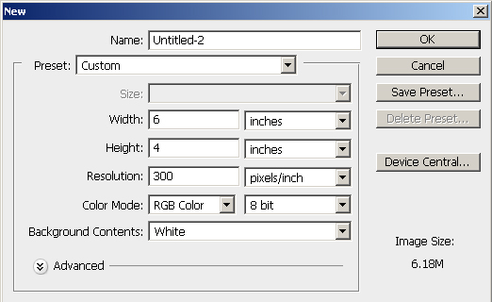
- You will create 3 different canvases for this project.

Step 1: Create a Canvas that is 4” x 6” [or 6” 4” – depending on the picture’s orientation] with 300 Resolution, by going File>New. Fill the canvas with black by pressing Ctrl+A, and then Edit>Fill and make sure to choose Black as the fill color.
Name the file: LN_FN_Gradient_#_WC [# = 1, 2, or 3]
Format = PSD

Step 2: Open a Photo that you want to blend [It MUST be a color picture!]. Copy the Photograph by pressing Ctrl+A [to highlight All of it], then pressing Ctrl+C [to Copy it] and then paste it on the new canvas that you have created by going to that canvas and pressing Ctrl+V [to paste it]. Make sure that your Photograph is sized to fit the new canvas. If the photograph needs to be resized, press Ctrl+T, and resize to fit the canvas.

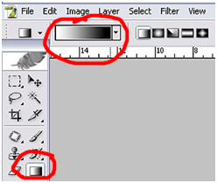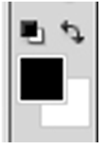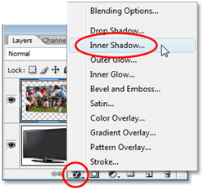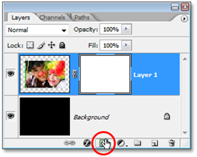Step 3: Be on the layer that you have just pasted on the canvas. Add a Layer mask by going to the bottom of the Layer Palette and selecting the Layer Mask icon. Go to the Gradient Tool and make sure that black is the Foreground color on your palette. Left click and draw a line from left to right or right to left depending on your Photograph. What will happen is the picture will fade out from the edge toward your Photograph. Black should come thru.
Gradient button
Foreground
Color
Layer Styles button
Layer Mask button

Layer Mask button

Step 4: Add White Text to your Photograph and add an Inner Shadow to it. Go to the Text tool and write a word or words that go with your Photograph. Add a Layer Style to your Text layer, such as Inner Shadow. Size the Text and place it on the canvas where it shows the best.

Example on next page.

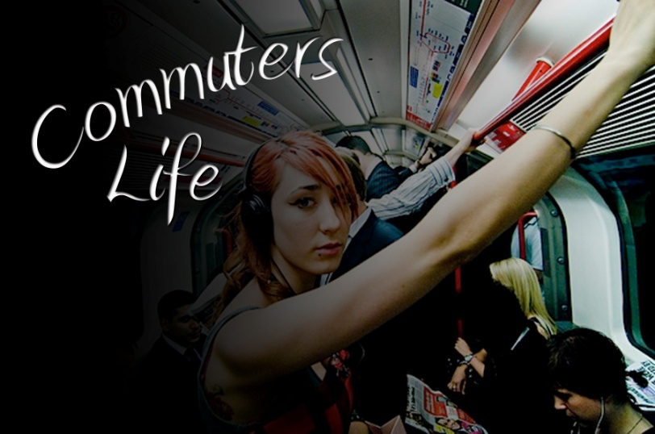
SAVING
- PSD: Save your PSD file
  - Select File > Save
  - OR use CTRL+S
- Change to JPEG: Select Save As…
  - Name: Change WC to Final
  - Format: Change to JPEG
    - This will flatten your image.
    - Quality = 12 = Maximum
  - Save to your Gradient_Layer folder.
- Do the same for your 2 other files.

TURNING IN your work
- DO NOT drag and copy your folder to the S:\ directory stated below.
  - For some reason, the files gets “locked” and they cannot be graded.
- Select Start > My Computer
  - Navigate to your Photo1_[last name]\Gradient_Layer folder
  - CTRL + Left click on each of the 3 Final JPEG files in the folder so that they are highlighted.
    - They should say “_final” at the end so they should be easy to find.
  - Right click on one of them and select COPY so the 3 files are copied to memory.
- Navigate to S:\Communications\Photography\4000 - Photo I\Student Drop\Teacher\ Assignment folder
  - Right Click and select Paste to place copies of your 3 Chrome effects in the specified directory.

There is NO grading sheet for this assignment.

